Deep Neural Network Concepts
for Resume-Job Description Matching
In-depth explanation of Sequential Models, LSTM, BiLSTM, Siamese Networks, Loss, Optimizers, Evaluation, Epochs, Bias, and Training Flow

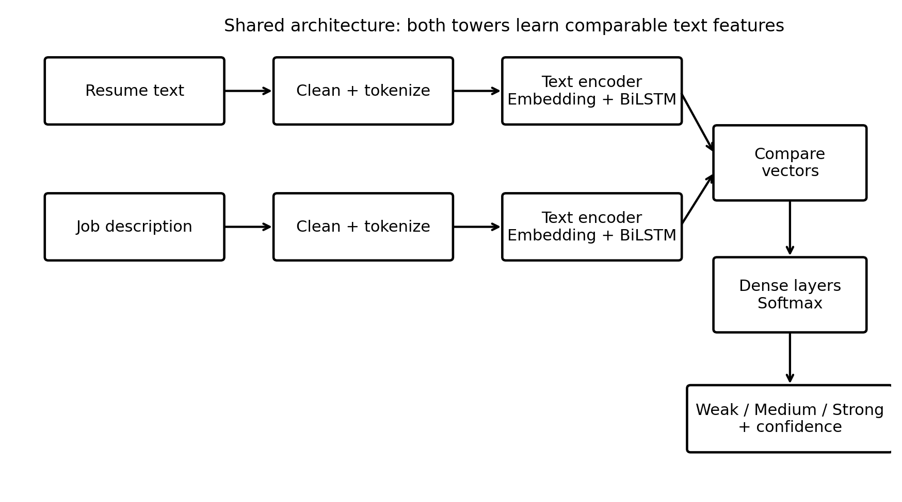
Figure 1. Proposed Deep Neural Network architecture for Resume-JD matching.

Project framing: This document focuses on a pure Deep Neural Network project, not a CrewAI or LLM-agent implementation. The goal is to train and explain a model that predicts whether a resume is a weak, medium, or strong match for a job description.

Table of Contents
- 1. Project context and learning goal
- 2. Big picture: what the neural network learns
- 3. Sequential models and why text needs sequence learning
- 4. RNN intuition and the vanishing-gradient problem
- 5. LSTM in depth: gates, memory, equations, and diagram
- 6. BiLSTM: reading text from both directions
- 7. Siamese networks: two towers, shared understanding
- 8. End-to-end Resume-JD architecture
- 9. How the Siamese model understands features
- 10. Loss functions
- 11. Optimizers and learning rate
- 12. Epochs, batches, iterations, and training loop
- 13. Weights, biases, and bias in data
- 14. Evaluation metrics and confusion matrix
- 15. Overfitting, regularization, and validation
- 16. Implementation blueprint
- 17. Glossary and teaching checklist

1. Project Context and Learning Goal
The project is a Deep Neural Network based Resume-Job Description Match Scorer. The model receives two text inputs: a candidate resume and a job description. It predicts whether the resume is a weak, medium, or strong match for the role.
This project is valuable because it teaches neural networks through a practical business use case. Students can see how raw text becomes numbers, how a sequence model learns meaning, how two documents are compared, and how the model is trained using labels.
Teaching note: The model is not expected to rewrite the resume. It predicts match quality. A separate application can later use this score for ATS feedback, ranking, or resume improvement suggestions.

Input | Model action | Output
Resume text | Encode candidate experience, skills, tools, projects | Resume vector
Job description text | Encode role requirements, skills, responsibilities | JD vector
Resume vector + JD vector | Compare similarity and difference | Weak / Medium / Strong match

2. Big Picture: What the Neural Network Learnt
The network learns a mapping from pairs of text documents to a relevance label. During training, it sees examples such as resume A with JD B equals strong match, resume C with JD D equals weak match, and so on. Over many examples, it adjusts weights so that similar resume-JD pairs move closer in representation space and mismatched pairs become easier to separate.
- A resume is treated as evidence of candidate capability.
- A job description is treated as a set of role requirements.
- The model learns patterns such as skill overlap, semantic similarity, role alignment, seniority clues, and missing capabilities.
- The output is a probability distribution over match classes.
Example output probabilities:
Weak Match = 0.08
Medium Match = 0.24
Strong Match = 0.68
Final class = Strong Match

3. Sequential Models and Why Text Needs Sequence Learning
A sequential model processes data where order matters. Text is sequential because the meaning of a word depends on nearby words. For example, “not experienced in Kubernetes” is very different from “experienced in Kubernetes”. A bag-of-words model may see the word Kubernetes but miss the negation. A sequential model can learn the context around it.
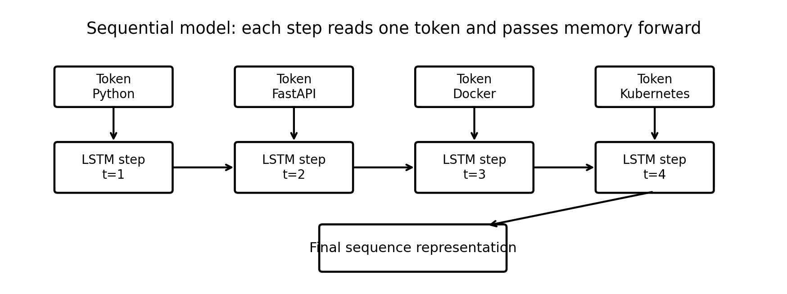
Figure 2. A sequential model reads tokens step by step and passes memory forward.
- Time step: one position in the sequence, such as one word or token.
- Hidden state: the model’s compressed memory of what it has read so far.
- Sequence representation: the final vector representing the whole text or a selected portion of text.
Teaching note: Sequential models are not only for time series. Any ordered data, including text, audio, logs, clickstreams, and transactions, can be modeled as a sequence.

4. RNN Intuition and the Vanishing-Gradient Problem
A Recurrent Neural Network, or RNN, reads a sequence one token at a time. At each step it combines the current token with the previous hidden state. This lets it carry memory forward. However, simple RNNs struggle with long sequences because gradients can shrink or explode during backpropagation through time.
Simple RNN idea:
h_t = activation(W_x * x_t + W_h * h_{t-1} + b)
- If gradients become too small, the model forgets long-range dependencies. This is called vanishing gradient.
- If gradients become too large, training becomes unstable. This is called exploding gradient.
- LSTM was designed to solve much of the long-memory problem using gates and a cell state.

5. LSTM in Depth: Gates, Memory, Equations, and Diagram
LSTM stands for Long Short-Term Memory. It is a special type of RNN designed to remember useful information for a long time and forget irrelevant information. It does this using gates. A gate is a small neural network that outputs values between 0 and 1. A value near 0 means block the information. A value near 1 means allow the information.
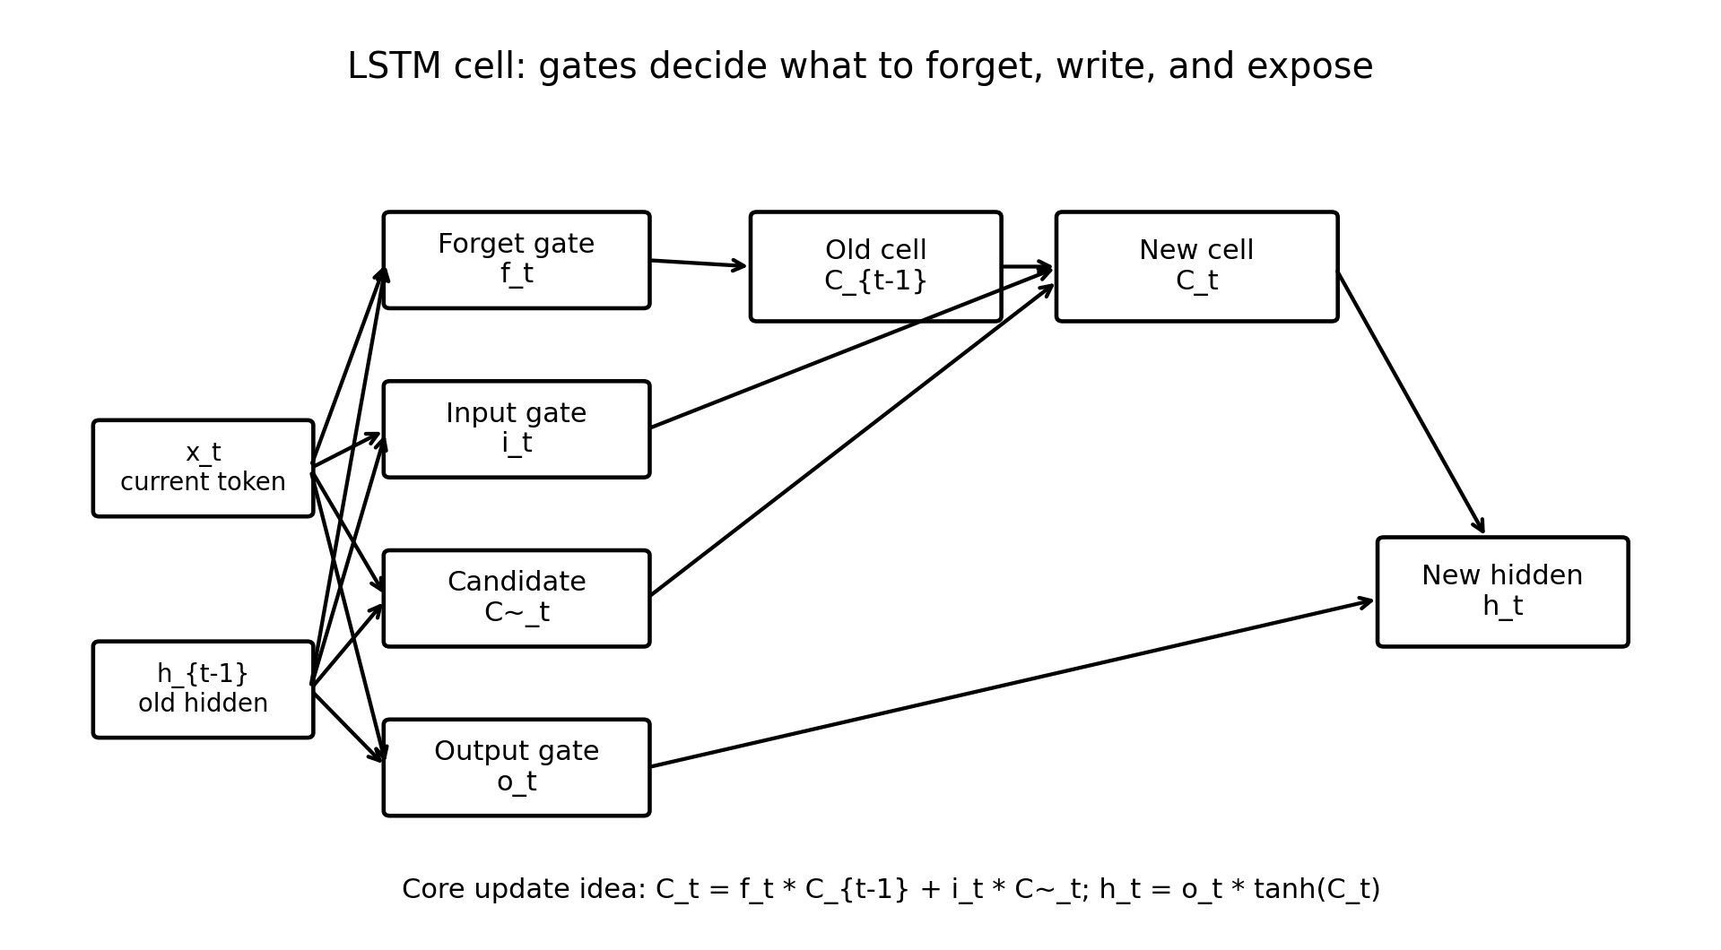
Figure 3. LSTM cell with forget, input, candidate, and output gates.

5.1 LSTM Inputs and Outputs
- x_t: the current token embedding at time step t.
- h_{t-1}: the previous hidden state, representing short-term output memory.
- C_{t-1}: the previous cell state, representing longer-term internal memory.
- h_t: the new hidden state.
- C_t: the new cell state.

5.2 Forget Gate
The forget gate decides what old memory should be kept or removed. In a resume, it may learn to keep important clues like “5 years Python” and reduce the importance of generic phrases like “hardworking individual”.
f_t = sigmoid(W_f * [h_{t-1}, x_t] + b_f)

5.3 Input Gate and Candidate Memory
The input gate decides what new information should be written into memory. The candidate memory proposes new content that could be added.
i_t = sigmoid(W_i * [h_{t-1}, x_t] + b_i)
C~_t = tanh(W_c * [h_{t-1}, x_t] + b_c)

5.4 Cell State Update
The new cell state combines kept old memory and selected new memory.
C_t = f_t * C_{t-1} + i_t * C~_t

5.5 Output Gate
The output gate decides what part of the internal memory should be exposed as the hidden state. This hidden state is passed to the next step or used for final prediction.
o_t = sigmoid(W_o * [h_{t-1}, x_t] + b_o)
h_t = o_t * tanh(C_t)
Teaching note: For students: think of the cell state C_t as a notebook, the forget gate as an eraser, the input gate as a pen, and the output gate as the final summary shown to the next layer.

6. BiLSTM: Reading Text from Both Directions
A Bidirectional LSTM uses two LSTMs. One reads from left to right. The other reads from right to left. Their outputs are combined. This is powerful for text because a word can depend on words before and after it.
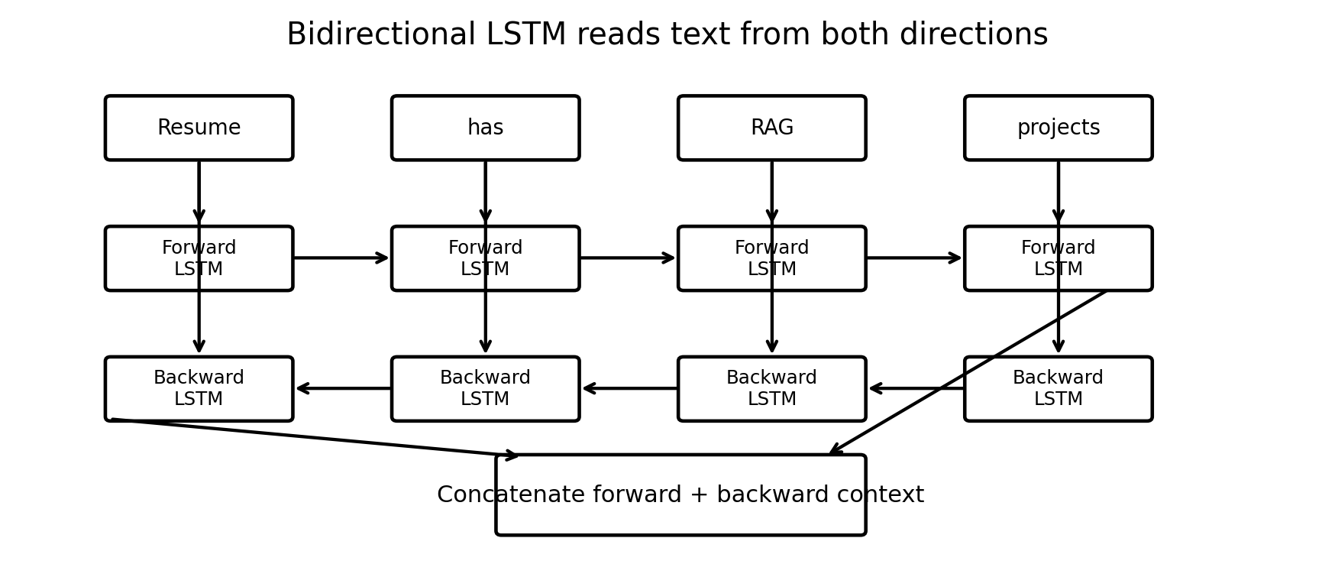
Figure 4. BiLSTM combines forward and backward context.
Example:
Sentence A: I have experience with cloud deployment.
Sentence B: I do not have experience with cloud deployment.
A unidirectional model may eventually learn the difference, but a BiLSTM has stronger context because each token is understood using both previous and future words.

7. Siamese Networks: Two Towers, Shared Understanding
A Siamese network is a neural architecture that compares two inputs. It uses two encoder towers. In many designs, the two towers share the same weights. Shared weights mean both inputs are processed by the same logic, so their output vectors become comparable.
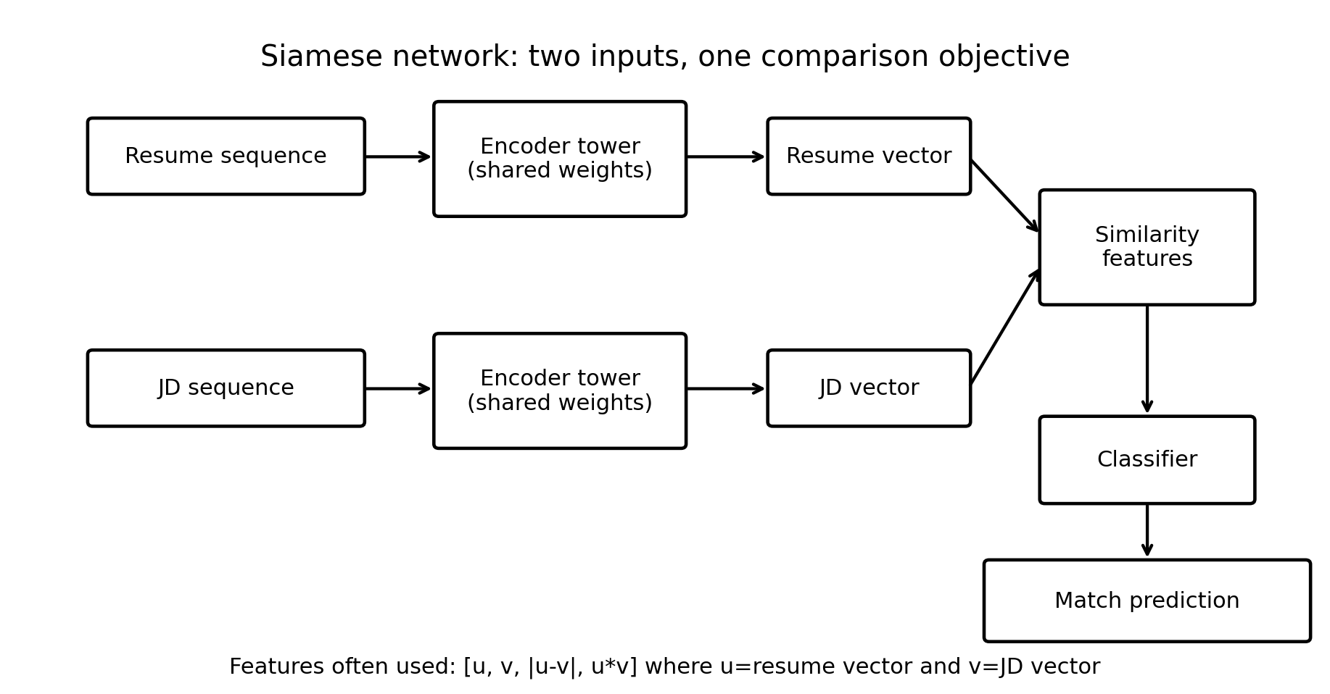
Figure 5. Siamese architecture for comparing resume and job description vectors.

7.1 Why Siamese Architecture Fits Resume-JD Matching
- A resume and a JD are both text documents.
- The goal is comparison, not just single-text classification.
- The model can learn whether two documents talk about similar capabilities.
- The architecture can reuse the same text encoder for both documents.
- The comparison layer can learn overlap, distance, and compatibility.

7.2 Shared Weights
Shared weights mean the same encoder parameters are used for resume and JD. This is like using the same evaluator to read both documents. If one tower learned that “RAG pipeline” is important, the other tower uses the same understanding when reading the other document.

8. End-to-End Resume-JD Architecture

Figure 6. End-to-end DNN architecture for Resume-JD match classification.
Stage | Input | Operation | Output
Text cleaning | Raw resume/JD | Lowercase, normalize spaces, remove noise | Clean text
Tokenization | Clean text | Convert words/subwords to integer IDs | Token sequence
Padding | Variable sequence | Make fixed length | Equal-size arrays
Embedding | Token IDs | Map tokens to dense vectors | Word vectors
BiLSTM encoder | Word vectors | Read sequence both directions | Document vector
Comparison | Resume vector + JD vector | Concatenate, absolute difference, product | Similarity features
Classifier | Similarity features | Dense layers + softmax | Match class

9. How the Siamese Model Understands Features
The model does not understand features the way humans do. It learns numerical patterns. During training, it sees many examples where certain combinations lead to strong, medium, or weak labels. Its weights gradually encode which token patterns, phrase contexts, and vector relationships matter.

9.1 Feature Learning in Layers
- Embedding layer learns word-level meaning and associations. Similar technical words can end up with similar vectors.
- BiLSTM learns phrase-level and sentence-level context. It can learn patterns like “experience with X”, “worked on Y”, or “lack of Z”.
- Pooling or attention compresses the sequence into a document vector.
- Comparison features tell the classifier how close or different the two vectors are.
- Dense layers learn nonlinear decision boundaries between weak, medium, and strong matches.

9.2 Comparison Features
u = resume vector
v = job description vector
Features used for comparison:
1. u
2. v
3. |u - v| # distance/difference
4. u * v # alignment/interaction
The absolute difference captures how far apart the documents are in feature space. The element-wise product captures where both documents activate similar dimensions. Together they give the classifier a richer signal than simple concatenation.

9.3 Example Interpretation
Resume: Built chatbot using embeddings and vector search.
JD: Build RAG pipelines using vector database and semantic retrieval.
The exact words differ, but the model can learn semantic closeness:
embeddings ~ semantic retrieval
vector search ~ vector database
chatbot with documents ~ RAG pipeline

10. Loss Functions
A loss function measures how wrong the model is. Training tries to minimize this loss. Lower loss means the model predictions are closer to the true labels.

10.1 Cross-Entropy Loss
For weak/medium/strong classification, use sparse categorical cross-entropy or categorical cross-entropy. If labels are integers 0, 1, 2, sparse categorical cross-entropy is convenient.
Loss = - sum(true_label * log(predicted_probability))
- If the true class is Strong and the model assigns high probability to Strong, loss is low.
- If the true class is Strong but the model assigns high probability to Weak, loss is high.

10.2 Regression Loss Option
If the task predicts a score from 0 to 1, mean squared error or mean absolute error can be used. But for this phase, classification is easier to teach and evaluate.
MSE = average((actual_score - predicted_score)^2)

10.3 Contrastive and Triplet Loss
Advanced Siamese models often use contrastive or triplet loss. These losses directly train embeddings so that matching resume-JD pairs are closer and nonmatching pairs are farther apart. This is powerful but slightly more advanced than Phase 1 classification.

11. Optimizers and Learning Rate
An optimizer updates model weights based on gradients from backpropagation. The optimizer decides how the model learns from the loss.
Optimizer | Idea | Pros | When to use
SGD | Move weights opposite the gradient | Simple and stable | Teaching basics, large datasets
SGD + Momentum | Smooth updates using past gradients | Reduces zig-zagging | When plain SGD is slow
RMSProp | Adaptive learning for each weight | Good for sequence models | RNN/LSTM experiments
Adam | Momentum + adaptive learning rate | Strong default choice | Recommended for this project
Learning rate controls the size of each update. If it is too large, the model may jump around and fail to converge. If it is too small, training becomes very slow.
Recommended starting optimizer:
optimizer = Adam(learning_rate=0.001)

12. Epochs, Batches, Iterations, and Training Loop
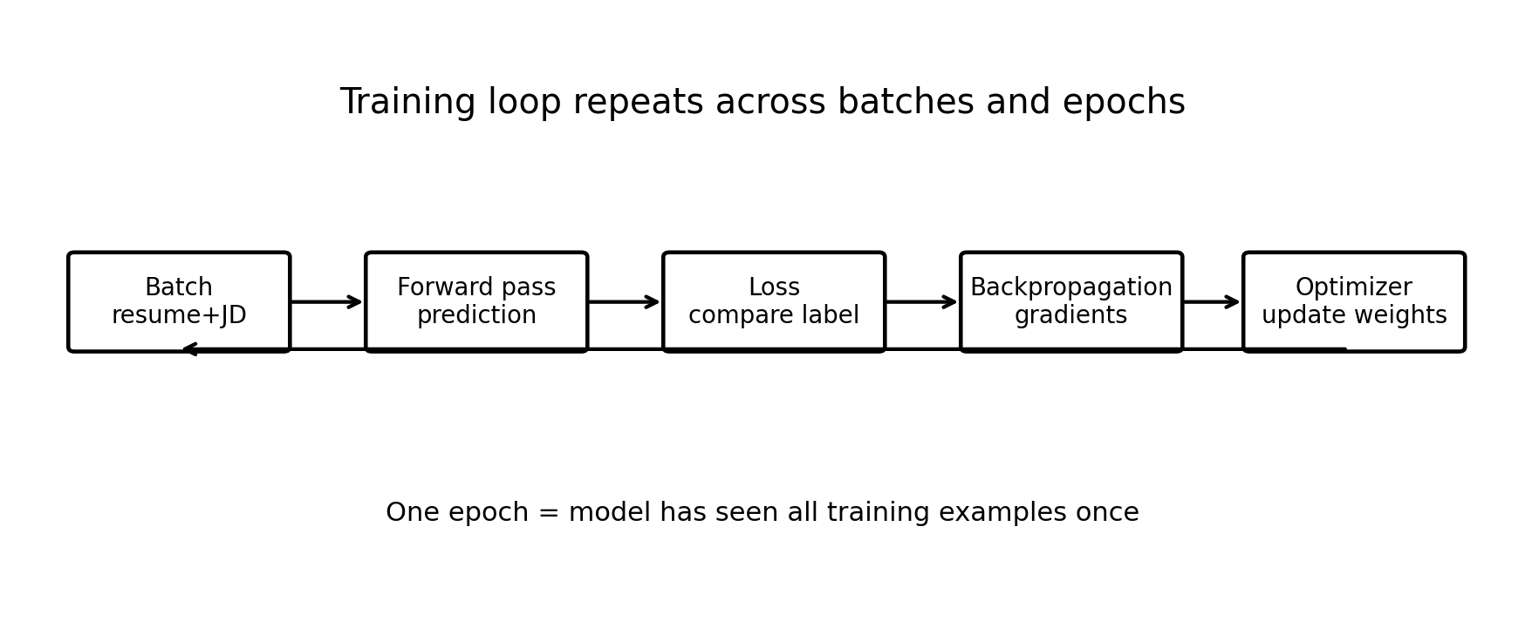
Figure 7. Training loop: forward pass, loss, gradients, optimizer update.
Term | Meaning
Epoch | One full pass over all training examples.
Batch | A small group of examples processed together.
Iteration / step | One optimizer update after one batch.
Forward pass | Model converts inputs into predictions.
Backward pass | Model computes gradients of loss with respect to weights.
Gradient | Direction and amount each weight should change.
Learning rate | Controls how big each update is.

Teaching note: If dataset has 1,000 examples and batch size is 32, one epoch has about 32 training steps. If you train for 10 epochs, the optimizer performs about 320 updates.

13. Weights, Biases, and Bias in Data
The word bias has two meanings in machine learning. First, a bias parameter is a learnable number in a neural network. Second, data bias means the training data is not representative or contains unfair patterns. Both are important but different.

13.1 Bias Parameters in Neural Networks
A neuron usually computes a weighted sum and adds a bias. The bias shifts the activation boundary and helps the neuron fit patterns that do not pass through zero.
z = w1*x1 + w2*x2 + ... + b
output = activation(z)
- Weights decide how strongly input features matter.
- Bias lets the neuron activate even when inputs are small or zero.

13.2 Data Bias
Data bias happens when training examples do not fairly represent the real world. In resume matching, this could happen if the dataset overrepresents certain job roles, regions, institutions, writing styles, or technologies. A biased dataset can produce biased predictions.
- Role bias: too many AI Engineer examples and too few non-tech roles.
- Keyword bias: model overvalues exact keyword overlap and undervalues transferable experience.
- Seniority bias: model may confuse long resumes with stronger match.
- Format bias: model may prefer resumes written in a specific template style.
Teaching note: For a responsible project, never use protected personal attributes such as gender, religion, caste, race, age, or marital status as model features.

14. Evaluation Metrics and Confusion Matrix
Evaluation tells us whether the model is useful beyond training data. For a three-class match system, do not rely on accuracy alone. Use precision, recall, F1-score, and confusion matrix.
Metric | Meaning | Why it matters
Accuracy | Overall percentage of correct predictions | Good quick summary but can hide class imbalance
Precision | When model predicts a class, how often it is correct | Important for strong-match recommendations
Recall | Out of actual class examples, how many model finds | Important to avoid missing good candidates
F1-score | Balance of precision and recall | Useful when classes are imbalanced
Confusion matrix | Table of predicted vs actual classes | Shows exact error patterns
Calibration | Whether predicted confidence is trustworthy | Important if scores guide decisions
Example confusion matrix:
Pred Weak Pred Medium Pred Strong
Actual Weak 40 6 2
Actual Medium 8 31 7
Actual Strong 1 9 36
In this example, the model often confuses Medium and Strong. That may mean the labels are subjective or the model needs better features and more training examples around borderline cases.

15. Overfitting, Regularization, and Validation
Overfitting happens when the model performs well on training data but poorly on new data. In resume matching, a model may memorize synthetic examples instead of learning general matching logic.
- Training accuracy high, validation accuracy low: likely overfitting.
- Training and validation accuracy both low: likely underfitting.
- Validation loss starts increasing while training loss decreases: stop training early.

15.1 Regularization Techniques
- Dropout: randomly disables some neurons during training to reduce dependency on specific paths.
- L2 regularization: penalizes very large weights.
- Early stopping: stops training when validation performance stops improving.
- Data augmentation: creates varied examples so the model does not memorize one writing style.
- Class balancing: ensures weak, medium, and strong classes are represented fairly.

16. Implementation Blueprint
The project can be implemented in Google Colab using TensorFlow/Keras. The structure below keeps the solution modular and easy to teach.
resume_jd_dnn_project/
├── data/
│ └── resume_jd_dataset.csv
├── src/
│ ├── preprocessing.py
│ ├── model.py
│ ├── train.py
│ ├── evaluate.py
│ ├── predict.py
│ └── explain.py
├── models/
│ └── resume_jd_match_model.keras
├── outputs/
│ ├── training_history.png
│ ├── confusion_matrix.png
│ └── prediction_result.md
└── Resume_JD_Deep_Neural_Network.ipynb

16.1 Dataset Schema
resume_text,job_description,match_label
"Python ML engineer with FastAPI and Docker", "Need AI Engineer with Python FastAPI Docker RAG", 1
- 0 = Weak Match
- 1 = Medium Match
- 2 = Strong Match

16.2 Recommended Keras Model Pseudocode
resume_input = Input(shape=(max_len,))
jd_input = Input(shape=(max_len,))
embedding = Embedding(vocab_size, embed_dim)
bilstm = Bidirectional(LSTM(64, return_sequences=True))
pool = GlobalMaxPooling1D()
def encode(x):
x = embedding(x)
x = bilstm(x)
x = pool(x)
return x
u = encode(resume_input)
v = encode(jd_input)
features = Concatenate()([u, v, abs(u-v), u*v])
x = Dense(128, activation="relu")(features)
x = Dropout(0.3)(x)
x = Dense(64, activation="relu")(x)
output = Dense(3, activation="softmax")(x)

16.3 Training Configuration
loss = sparse_categorical_crossentropy
optimizer = Adam(learning_rate=0.001)
metrics = accuracy
epochs = 10 to 20
batch = 16 or 32

16.4 Prediction Output
Predicted class: Medium Match
Confidence: 72%
Common skills: Python, FastAPI, Docker
Missing skills: RAG, Vector DB, Kubernetes
Recommendation: Improve project bullets around RAG and deployment.

17. Glossary and Teaching Checklist
Concept | Simple explanation
Token | A word or subword converted to an ID.
Embedding | Dense vector representation of a token.
Sequential model | Model that processes ordered data step by step.
RNN | Neural network with memory across sequence steps.
LSTM | RNN with gates and cell state for long memory.
BiLSTM | Two LSTMs reading forward and backward.
Siamese network | Two-tower network designed to compare two inputs.
Loss | How wrong the prediction is.
Optimizer | Algorithm that updates weights to reduce loss.
Epoch | One full pass through the training dataset.
Batch | Small group of examples processed together.
Bias parameter | Learned offset in a neuron.
Data bias | Unrepresentative or unfair patterns in training data.
Evaluation | Measuring model performance on unseen data.

